**Network Security**

Penetration Tools for Network security

Project Report

Network Design and Computer Management Continuation

2013

Author: Daniel Klasson, Kim Klasson & Anatoly Iourtchenko

Supervisor: Olga Torstensson

Examiner: Malin Bornhager

###### Preface

In this initial text a very informal motivation for the work can be expressed and the intended reader may be described. Here also any potential acknowledgments may be given, i.e. thanks and credits to any people, companies, foundations etc. that have helped in the progress of the thesis work.

###### Abstract

The abstract very concisely summarizes the results of the thesis and their implications.

**Figures**

Cabled Figures

Figure 1.1 Tihiiii 1337

Wi-Fi Figures

Figure 2.1 Tihiiii 1339

**Content**

1 Introduction 6

1.1 Background 7

1.2 Project Goal 7

1.3 Objective 7

1.4 Methodology 8

2 Theoretical Background 9

2.1 Network Security 9

2.2 What is Network Security 9

2.3 What is a Penetration Tool? 10

2.4 Types of Security Threaths 10

2.5 Network Attacks 11

2.6 What is a Network Attack? 11

2.7 Types of Network Attacks 12

2 Cabled Network 13

2.1 Theoretical Metod 13

2.2 Theoretical Metod 13

2.3 Theoretical Metod 13

3 Wi-Fi Wireless Network 14

4 Cabled Network Results 15

5 Wi-Fi Wireless Network Results 16

5.1 Penetrating WEP key 16

5.2 Cracking WPA/WPA2 PSK/TKIP AUTO 20

6 Discussion 31

Appendix 32

References 33

Chapter 1

# Introduction

## Background

Wired and wireless network (Wi-Fi 802.11b, g, n, ce) is becoming more and more familiar in our offices, headquarters, schools and homes. They connect and bring people to the Internet. In connection with the development it is becoming easier to detect security holes. This means that, you, as an individual, civil or businessman always are in a vulnerable position. The security is now more important than ever and has a great impact on the future if the development shall go in the right direction.

Every day there are attacks against us individuals, civilians and entrepreneurs. It may be your Facebook account. When you are at home or your company and log on with your personal password through Facebook Mobile Application. Without the slightest knowledge is your personal life suddenly in someone else's hands. Faster than you can discover that your Facebook account has been hijacked, the person with the right knowledge and interest has already been received enough information for example full name, email address, phone number, social security number, passwords and the worst thing you can imagine, your bank account

To avoid this, the network penetration is extremely important for today's development. No one wants their information available for the wrong person, for example hackers that can steal, share or sell the information for their own profit.

In this project, it will be demonstrated how to reveal security holes by using the same methods as an outside attack. By then you can see if your own network really is as protected as you think. By demonstrating, which is the goal of the project, we can find out how the vulnerability becomes a real risk. With the help of the security holes that we are usually unaware of, a data breach can easily be done.

Through auditing tools, VLAN-abuse and a setup of VLANs on Cisco switches can we exploit VLAN and try to find VLAN tags. Using password cracker in Backtrack will we be able to identify telnet passwords and log information on a router or switch.

Via Wireless signals the client host computers can receive wireless signal packets trough WLAN-adapters (Wireless Local Area Network) that is connected to a Wi-Fi access point (wireless router). Wi-Fi networking protocol provides many different services and other protocols.

Therefore we want to show how to avoid getting access to your own Wi-Fi network-Access Point (wireless router) through full control of all the services and protocols in the Wi-Fi network that is cracked. Exploration of WEP attacks, WPA, WPA2 and WPS attacks, de-authentication (Wi-Fi denial of service attacks), sniffing on the ports will also take place, as well as access to other services and unknown areas of the Wi-Fi network.

## Project Goal

The goal of the project is to demonstrate what we have learned and the results we have achieved. By testing, demonstrate and report the security of wired and wireless network, we can achieve these goals and to gain a greater insight into network security by applying our skills and interests, which gives us more experience and knowledge that we will take with us to our future professional life. The points below summarize the goals we want to achieve with the project.

**Problem:** Security risks in wireless and cabled networks.

**Goal:** Discovering and understanding the vulnerabilities in a network.

## Objective

To achieve our goal with this study, we will explore and discover different tools to penetrate and hack into wireless and wired networks. The purpose and the goals of the project is to find out how to crack, hack and exploit wireless(Wi-Fi 802.11a, b, g, n) and cabled networks.

* Wi-Fi attacks on encryption protocol (WEP, WPA/WPA2/WPS, denial of service, sniffing out data from other computers on the network.)
* Cable Network Attacks on Cisco devices to test, demonstrate and report the weaknesses and strengths of the cabled network protocols (VLAN, VTP).
* Find and explain the options for strengthening of Wi-Fi networks and cable networks.

## Methodology

Through various penetration tools that we have chosen together, we have been able to demonstrate how insecure the network really is.

**Tools used:**

* Airodump-ng
* Aireplay-ng
* Aircrack-ng
* Reaver
* Set Tool Kit
* Cisco Auditing Tool
* Wireshark
* Yersinia

We divided the work into two parts, wired and Wireless network. Through good communication and collaboration, we could all, in spite of divided work, learn, and test on both the wired and the wireless part. By working with the project in a timely manner and together guide and motivate each other to always be one step ahead of schedule, we were able to reach our goal which among other things was to demonstrate the weaknesses and strengths in cabled and wireless network protocols.

The tests were conducted in Cisco lab at Halmstad University and with own equipment. Windows server 2008 64bit , DLINK DIR-615 WLAN AP, DLINK DWL-G122 WLAN adapter, And Backtrack 5 R3.

**Goals Achieved:**

* Wi-Fi Traffic
* Sniffing User Traffic
* Exploitable Security Gaps
* Exploit VLAN
* Password Cracking
* VTP Cracking
* VLAN Abuse
* SQL injection vulnerabilities
* WEP Hacking
* WPA/WPA2 Hacking
* WPS Hacking
* Deauthenticate Attack
* Analyze Traffic

*(Will be updated or changed continuously)*

**Chapter 2**

# Theoretical Background

## Network Security

This part focuses on the foundations of network security. Here you can read about why security today is so important and the types of security you want to avoid.

## What is Network Security

For many people, security means many different things. Everyone defines safety in their own way. Network security for us is something that provides safety and protects us from attacks on our network, business, usability, integrity and confidential/personal data.[1]

The security threats today are significantly larger than it was before. Today, there is no requirement for great knowledge to succeed with an attack that another person would see as impossible.

Before we begin to discuss what types of threats there are and what types of attacks there are, it may be helpful to know the different terms of which kind of person who is behind a particular attack. List of the most common terms:

* White hat - A person looking for security holes to create a stronger and more secure network for a company. [2]
* Hacker - A person whose mission is to find unauthorized information on a network in the form of revenge, hatred or for other purposes. [2]
* Black Hate - The opposite of White Hat. Instead of helping the victim, their mission is to find security holes and use it for their own benefit. [2]
* Cracker - A more specific term for someone who practice white hat and black hat.[2]

## What is a Penetration Tool?

In this world of heavy computer communication, the demand of security is rising to new levels. More and more information are stored on computers each day. New systems and software are developed and have pros and cons in terms of security.

While we are sitting here and reading this, websites are hacked, database information is stolen, passwords are cracked and the systems are demanding new ways to secure them.

Here is where the Penetration tools come in. With this type of tool, companies and other parties can test and verify their own infrastructure security by stress testing and finding holes in their computer environment on all levels. This can be to find weaknesses on their website, if it’s possible to execute codes and special characters or to exploit other methods to gain full access to all the information in the database. Penetration tools such as(Backtrack, an OS Linux Distribution) can be used to verify and fix issues such as:

* Antivirus exploits
* Network stress testing(VOIP, WLAN, DoS)
* Operating system backdoors
* Priviliges Escalations in OS(password attacks, spoofing attacks)

With this tools IT personnel in companies, firms and government can test the security, reliability and stability of their IT and computer systems and find ways to secure these holes and vulnerabilities.

## Types of Security Threats

When you talk about the types of security threats that exist, usually you divide them into four categories:

* Unstructured Threats - Form of White hat or black hat. A person who is looking for security holes for either a good cause or for personal benefit.[2]
* Structured Threats - Regarding Structured threats, it is common to say that it is either a person or a group of people with some knowledge and interest in hacking. In other words, a group that fits into the form of black hat. There is a well-known group that fit into this category.[2]
  + This group calls themself "Anonymous" and is simply a group that is looking for companies or government agencies to commit either fraud or for fun creating havoc in the form of a virtual demonstration. Everything from hatred, revenge or form of political opinion.
* External Threats - A threat to a company by either an individual or a group who do not have access to approved computer systems and networks outside the company. Takes the form of intrusion from either the Internet or servers. A mixture of Unstructured and Structured threath.[2]
* Internal Threats - A threat to a company by either an individual or a group that has access to approved computer systems and networks outside the company. Takes the form of intrusion from either the Internet or servers. A mixture of Unstructured and Structured threath.[2]

## Network Attacks

This part focuses on the foundations of network attacks. Here you can read about what is defined as a network attack and the types of attacks that exist today. The first two attacks are part of the project work. You will be able to read about them further in the report. The other two are also very important and interesting.

## What is a Network Attack?

Network Attack is an attempt to access network drives, exploiting security holes or sniffing of traffic to access unauthorized information for example passwords. For some people it is something They do for fun, other people do it for Their Own benefit or for a good purpose..

## Types of Network Attacks

Just as security threats, the network attacks is divided into four different categories.

* Reconnaissance - Unauthorized access of network devices. Unstructured Threat in the form of either White Hat or Black Hat. Such an attack may consist of the following form: Internet information queries, Ping Sweeps, Port Scans and packet sniffers. [2] More about these Reconnaissance Attacks can be found in chapter.......
* Access - Take advantage of a security hole where encryption of account or password is missing. [2] Demonstrating of this can be found in chapter.............
* Denial of Service - Attack of a system where the goal is to create network congestion with the results of the system crashing or working so slowly that it is basically completely useless.[2]
* Worms, Viruses and Trojan Horses - A program or text documents that are looking to either injury, read information or deny access to systems, networks or other services.[2]

Chapter 3

# Cabled Network

## Abuse VLAN

To be able to do this test you must have access to cisco switches and routers with three or four computers, one or two of them with BackTrack5. You also have to set up a topology. In this test we were using two topologies as the first one failed.

In figure (3.1) you can see the first topology that we were using. By implementing an ACL (Access Control List) in the configuration for the switch and router, we want to block VLAN 200 from getting access to VLAN 20.

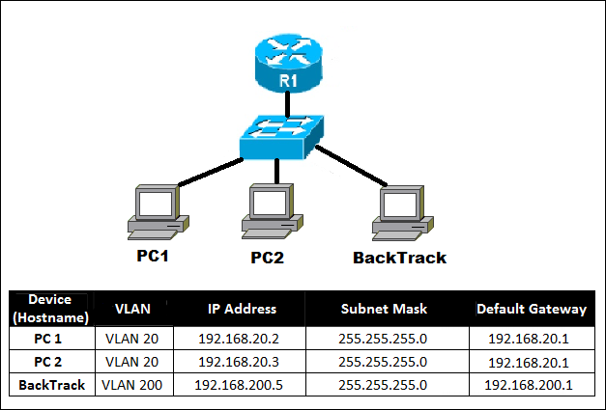

*Figure (3.1) – The first topology we were using.*

In figure (3.2) you can see the second topology that we were using. In this topology we added one computer with BackTrack5 and put it in the same VLAN as the other BackTrack5 computer (VLAN 30). Just as the first topology, we use an ACL, except that we now want to block VLAN 30 to get access to VLAN 10 and VLAN 20. As you can see in Appendix () we also improved the configuration in the second topology.

To set up an IP address in your BackTrack5 computer you open a new terminal and write the following command:

* #ifconfig eth0 (ip address) netmask (netmask)

To see information of your interface you just type the following command:

* #ifconfig

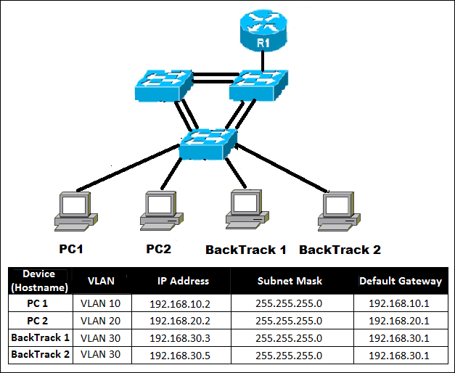

*Figure (3.2) – The second topology we were using.*

The first step before we can abuse VLAN is to check so there is any connection out to the interface. To check this we used both the command #ping in terminal to ping our gateway and the other BackTrack5 host and Wireshark to capture CDP- and DTP-frames. Unfortunately as you can see in figure (3.3) only CDP-frames showed up as we captured the traffic, even if we waited 10 minutes.

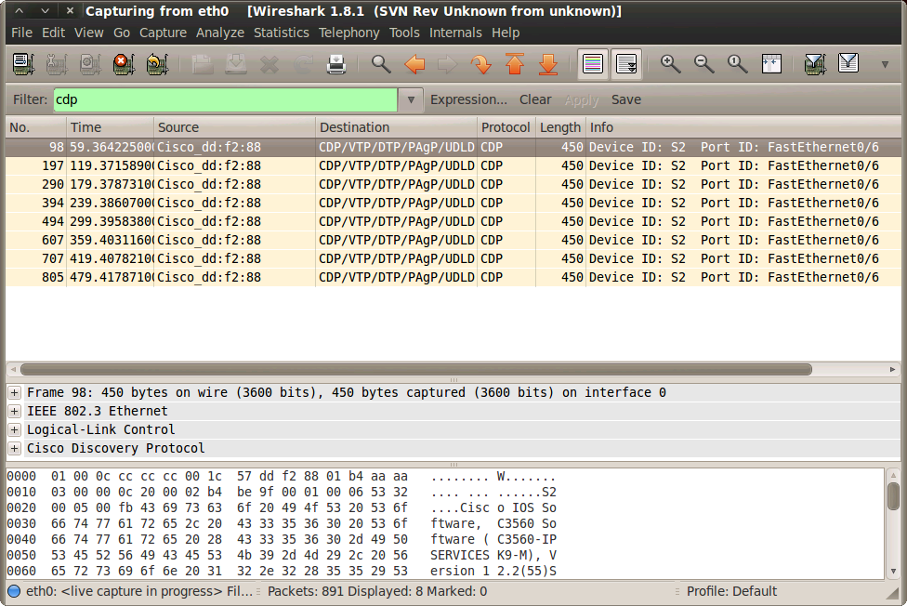

*Figure (3.3) – We could only see CDP in Wireshark as we captured the traffic.*

To be able to abuse VLAN we first had to tell the switch that the port our BackTrack5 computer is connected to is a trunk port. To do so we used a tool called Yersinia by typing in terminal the following command:

* #yersina -G – The G stands for GTK Mode.

Next step is to launch a so called DTP attack. By clicking the Launch attack button in Yersinia and tab to DTP in the new popup window we choose to enable trunking and then press OK. Now that we have lied to the switch that we are in trunking mode, we should be able to see three different status in Yersinia - ACCESS/AUTO, ACCESS/DESIRABLE and TRUNK/AUTO.[3] As figure (3.4) illustrates ACCESS/DESIRABLE was the only status that showed up.

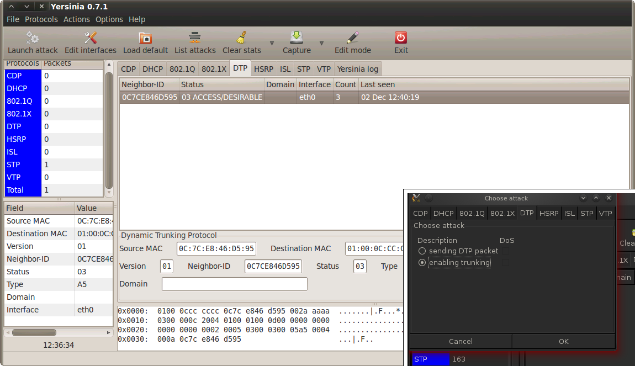

*Figure (3.4) – This picture illustrate how to launch a DTP-attack and the result we got.*

The final step to get full access to another unprotected VLAN is to add that VLAN to our interface in BackTrack5. In this test we wanted to get access to VLAN 20. Thereby you write the following command in terminal:

* #modprobe 8021q – This command loads the 8021q module that is needed.
* #vconfig add eth0 20 – This command adds VLAN 20 to our interface
* #ifconfig eth0.20 up – Makes the interface go up
* #ifconfig eth0.20 (ip address) netmask (netmask)

With a #ifconfig we can see our interface as figure (3.5) illustrates.

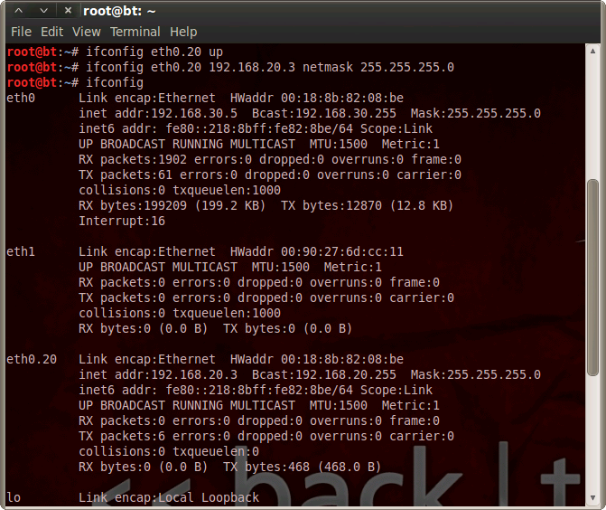

*Figure (3.5) – VLAN 20 is added to BackTrack5 interface.*

## Password sniffing with Cisco Auditing Tool

Cisco Auditing Tool is a cisco tool that is used for three purpose.

* Telnet password attack
* Show IOS history
* Brute force the SNMP community string

In this test we wanted to sniff a password that we were using in our cisco router configuration. As most of today’s cisco equipment are using SSH (Secure Shell) to encrypt the information and traffics this tool is mostly outdated.[4] Telnet sends everything in plain text, so it would be very stupid to have Telnet activated if you are working seriously with networking. This test is just for demonstration purpose.

To start Cisco Auditing Tool you just write the following command in your Terminal session:

* #cd /pentest/cisco/cisco-auditing-tool/

If you type #./cat you can see a list of options to use with this command. We want to sniff passwords from a host (our gateway to router) so by looking at this options list we can see that we want to use -h (for scanning a single host) and -a. (using a wordlist for password guessing) as figure (3.6) illustrates.

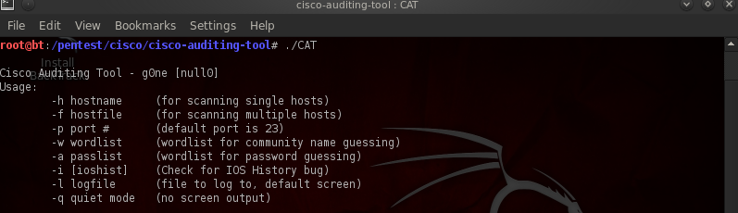

*Figure (3.6) – Cisco Auditing Tools option list.*

To be able to do this test we also had to create a password list. You can do this by terminal or by finding your way to Cisco Auditing Tool folder in root. As you can see in figure (3.7) we did the second option by in the folder create a new file where we wrote some few normal passwords often used in cisco devices.

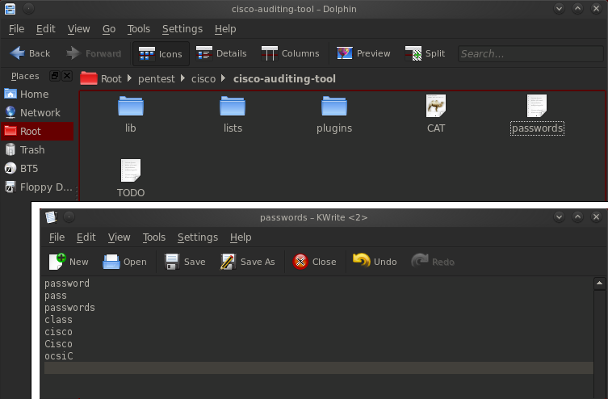

*Figure (3.7) – A password list with the most common passwords.*

The last step to sniff a password we had to write the following command in terminal as figure (3.8) illustrates:

* #./cat -h (ip address) -a (password list)

The host we were sniffing from was the gateway to the router (192.168.200.1) and we took help of the password list we created (passwords).

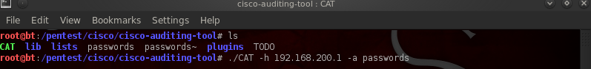

*Figure (3.8) – This picture illustrates how to start sniffing.*

## Account sniffing with Intercepter

The last test we did on the cabled part is not far from different than sniffing a password with Cisco Auditing Tool. In this test we were using a tool called Intercepter-ng. It is a powerful tool you can use when you want to spy on something. In this test we used it to sniff username and password when someone tries to log in to the router via a browser.

You can find Intercepter-ng by finding your way via BackTrack – Privilege Escalation – Spoofing Attack – Network Spoofing – Intercepter-ng.

As figure (3.9) demonstrates a new window popped up. In this window we can see how to use the tool and our active interface we want to use for searching for other hosts.

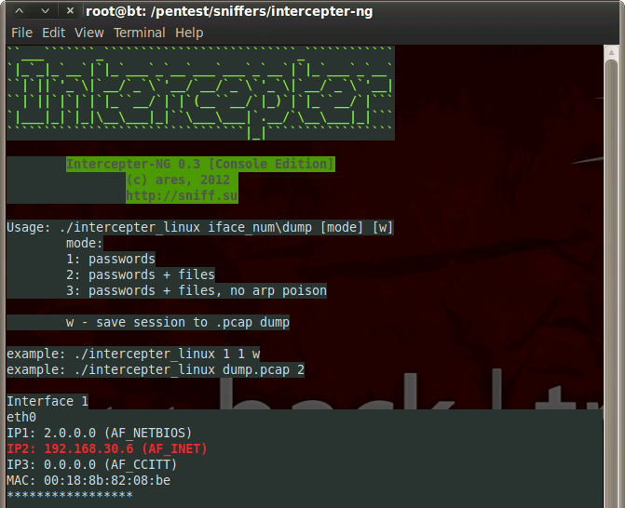

*Figure (3.9) – The prompt when starting Intercepter-ng.*

In this test we want to sniff passwords. So by taking our first interface (1) with password mode (1) and w to save our session we can log traffic between our interface and the router.

Start the session by typing the following command in terminal:

* #./intercepter_linux 1 1 w

As figure (3.10) illustrates Intercepter-ng first scans thru the network for other hosts. In this test the tool found our gateway to the router and thereby started the log session.

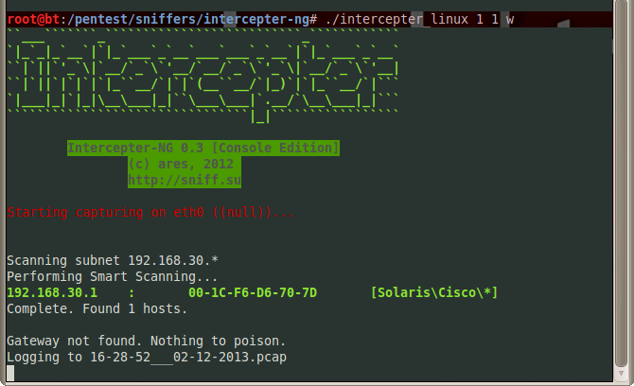

*Figure (3.10) – Intercepter-ng found our gateway and started a log session.*

Chapter 4

# Wi-Fi Wireless Network

Here the models and methods are formally presented. Also basic results and properties are mentioned and references to the current development of the methods in the literature are also given.

## Penetrating WEP key

In order to do this you must have a Wireless Network adapter which supports packet injections and monitoring mode (sniffing mode). On figure () you can see a list of compatible cards which supports BackTrack5. We assume that you already have a card that supports BackTrack5 and that you are ready to run these commands that will be demonstrated in the next pages.

After booting the BackTrack5 we must ensure that the wireless card is recognized and supported. To do this, open a new terminal window.

**To list the network, use the following command:**

1. # iwconfig – This command lists all the network adapters that are installed on the system. You can also use # ifconfig which provides additional information on the interface that you are working with.
2. The following command, figure (), will put the wireless adapter into listen mode (monitor mode):

* #airmon-ng start wlan0

Figure () shows that monitoring mode is enabled on mon0.

Now is the time to capture the packets. We have several options here. You can select all channels or a more specific target. First we will choose to dump the traffic of all the Wi-Fi channels in a dump file (. Capfile). This file will be created after the initiation of the following command:

* #airodump-ng -w (filename) mon0

-w can be anything, for example: -w dumpfile3. This will be our cap file ending with .cap extension.) Look at figure ()



*Figure () - Turns the wireless adapter into listening mode (monitor mode))*



*Figure () - Here you choose #airodump-ng -w dumpfile3 mon0, to distinguish it from other previous dump files that was created.*

1. Now we scanned our Wi-Fi area. Then it's time for a more specific dumping of wireless packets. In this way, we want our own access point that you can see in Figure ().

**ESSID:** anatolywifi - with WEP 64-bit encryption.

Now that we know what traffic we want to listen to, we execute the following command (figure ()):

* Airodump-ng -w (filename) -c (choose a channel) –bssid (wireless access point MAC-address).



*Figure () - How you perform specific dump targeting on the mac-address of the Wi-Fi access point.*

We are now ready for some more lethal attacks against this weak WEP encryption. We will show how to run the aireplay-ng. How it will make this access point to vomit so much data packets that we will be able to gather enough data packets to crack the WEP-password to enter and authenticate with this access point.

**Fake authentication injection (figure ()):**

* aireplay-ng -1 10000 -a (access point mac-address) -h (our mac-address) mon0

**Step 1**

Keep these commands running in a terminal window!



*Figure () - Fake authentication injection.*

**Step 2**

Fake ARP requests.

**Enter following command (figure ()):**

* aireplay-ng -3 -b (access point mac-address) -h (our mac-address) mon0.



*Figure () - Fake ARP request.*

The command on step 2 is very robust and makes the access point nearly exhaust itself from the fake ARP requests. It starts spitting out fast data packets after the commands that we used on step 1 and step 2.

You don't have to do both step 1 and 2. It may be enough with just step 2. After some tests we found that aireplay-ng -3 command is the most important here. It will gather enough packets even without the step 1 command.

Now we have everything we need and can start by opening the dumpfile, dumpfile4-01.cap (figure ()).



*Figure () - Opening of the dumpfile.*

This is a 64-bit WEP key that was configured on the D-Link DIR-615. The 128-bit WEP key is longer and consists of 26 hexadecimals. This one consists of 10 hexadecimals. The procedure is the same for cracking WEP 64 & WEP 128-bit encryption. You may need more data packets from the accesspoint to be able to crack it. But as long as you are managing to gather packets, fake authentication works and the robust fake ARP request on the step 2 command, you will be able to crack the 128-bit WEP.

## Cracking WPA/WPA2 PSK/TKIP AUTO

1. The process of WPA/WPA2 needs a different approach than WEP. First we will start listening on the access-point and the channel it’s on.

To listen to our access point with ESSID anatolywifi, we use the following command (figure ()):

* airodump-ng-w (filename)-c (channel)-BSSID (AP MAC address) (interface)



Figure () – Listen to the ESSID anatolywifi.

1. Deauthentication - We must deauthenticate an authenticated user from the access point: anatolywifi. To deauthenticate our desktop computer, which is associated and authenticated with access point anatolywifi, enter the following command (figure ()):

* Aireplay -0 1-a (AP MAC address)-c (client mac address) mon0



*Figure () – Deauthenticate a user from the access point.*

To deauthenticate all clients on the access-point, you can issue the following instead of a specific client. This command will DoS everyone on Access point:

* Aireplay -0 1 -a (access-point mac-address) mon0.

1. Verify that you captured the three-way handshake between the client we deauthenticated and the access-point anatolywifi into the dumpfile. If it's success then you can start bruteforcing the handshake with dictionary file that contains thousands or millions of words.



*Figure () - ????*

1. Now that we have captured WPA handshake between Access-point anatolywifi and the client (the other pc that we deauthenicated) we can start bruteforcing the handshake. To begin we will use our own downloaded dictionary files with .txt extensions. These dictionary files will be transferred to same directory as the dumpfile for convenience purposes.



*Figure () - Dictionary file with .txt extensions.*

To test that it works, the WPA-password will be stored in this .txt dictionary file.

1. Now we can begin to bruteforce the dump file that captured the handshake (figure ()):

* Aircrack-ng (dump file) -w (dictionary file)



*Figure () - Capture handshake.*

This is how you crack a WPA, PSK/TKIP or AUTO password. The procedure is the same for all WPA options except EAP that requires a different method that is also harder to crack. The WPA/WPA2 PSK / TKIP make no difference when attacking these dumpfiles. If the handshake is captured from a successful authenticated user with the password cracked in the dictionary file.

## Cracking WPS

The WPS (Wi-Fi Protected Setup) authentication protocol is used in many homes and small businesses access points. On figure () you can see how to crack the PIN code, WPS authentication. The program we will use is called Reaver. There is a specially designed program to crack WPS enabled accesspoints. This program must be downloaded manually using the terminal, extracted and installed on Backtrack5.



Figure () – Crack PIN, WPS Authentication.

After some time, the WPS pin is cracked and also the WPA password. This is a serious vulnerability of WPS-enabled access-point. No matter how strong the WPA password you have, the result will be devastating. It will not matter what letters or how long the WPA password is. So we strongly recommend turning off WPS on accesspoints.

## Hi-Jacking

By spoofing the DNS in Backtrack5, we redirect all traffic going through our access-point to the BackTrack5 pc. It does not matter what you do or write on Facebook. You will always be connected to the cloned Facebook page that we copied using the Set Tool Kit.

1. To start this attack you must first edit this file, in figure ().

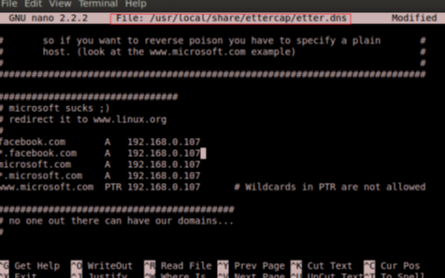Figure () - ?????

1. Launch Set Tool Kit, this tool is integrated in BackTrack5 distribution. So no installation needed. After we have edited the etter.dns file we can go to the next step which is to launch Set Tool Kit.

To launch this tool kit. Enter the command on figure () below:



*Figure () - ?????*

After you have changed to the above directory, write the following, in figure ().



*Figure () -????*

1. After you launch Set Tool Kit, enter option 1, in figure ().



*Figure () - ?????*

1. Choose option 2, in figure ().



*Figure () - ????*

1. Choose option 3, in figure ().



*Figure () - ?????*

1. Choose option 2, in figure (), and it will ask what IP-address you want to use. We enter our own IP-address of the Backtrack5 laptop that we associated with access point anatolywifi.



*Figure () - ????*

1. Next the Set tool kit will ask for website that we want to clone, so we enter [www.facebook.com](http://www.facebook.com), in figure ().



*Figure () - ????*

Open up a new terminal window and enter following command, in figure (). This command starts spoofing the DNS server of the access-point and redirects all traffic that starts with *.facebook.com to 192.168.0.107(the BackTrack5 laptop). Next it will check the whole subnet mask of the ip range 192.168.0.0 and list all hosts connected to the Access-point.



*Figure () - ???*

Chapter 5

# Cabled Network Results

## Abuse VLAN Results

As we were doing this test, we failed at more than one part. The first topology that we were using was catastrophic. The configuration in the switches and routers was so confusing that we had to start over with a whole new topology with a better configuration and better structured. But the results were nothing better.

If all steps to abuse a VLAN is correct we should be able to ping to that VLAN we had set up.[3] But when we tried to ping to a host in that VLAN (VLAN 20) we failed.

## Password Sniffing Results

In this test we successes with sniff our telnet password in the cisco router. As figure (5.1) illustrates the tools search thru every password that we had typed in the text file. As you can see in the figure, our password was cisco. And with this information we could start e telnet session with the router and start to play with the configuration.

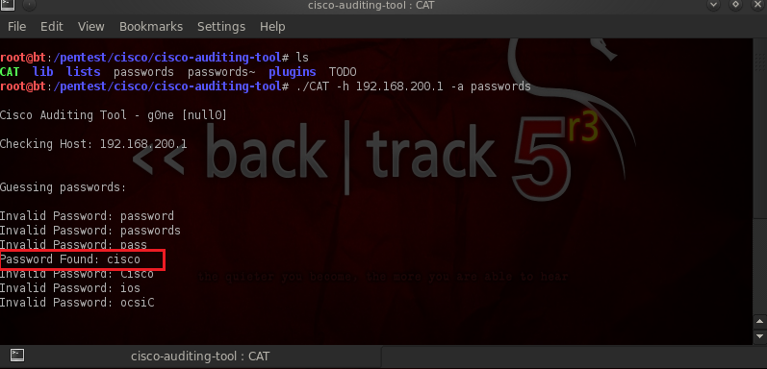

*Figure (5.1) – The result successes and we found a password.*

## Another Password Sniifin shit What borde rubriken vara?

When we did this test we got more information than we expected. We only wanted to get the password. But when we logged in to the router via the browser using a username and password, we also could see information about the username to the router as figure (5.2) illustrates.

The only problem with the username was that the last letter or number disappeared. But for the truth it is not that hard to guess the last letter or number. In this test our username was KIMDAN and the password was cisco.

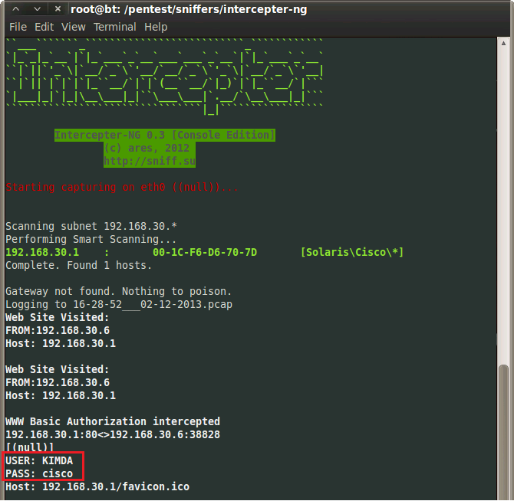

*Figure (5.2) – The results we got after logging in to the router via a browser.*

Chapter 6

# Wi-Fi Wireless Network Results

## Cracking of WEP-128bit Results



Figure () - ??????

## Cracking WPA/WPA2 PSK/TKIP AUTO Results



*Figure () – Bruteforce Results.*

## Cracking WPS PIN Results

This is the result from letting Reaver do its attack on our access-point.



*Figure () - ??????*

After WPS is cracked the Reaver steals the WPA password no matter how the WPA password length and complexity is.

***Note: Since it is very serious and highly illegal, we do not explain in detail how to proceed with this crack.***

## Hi-Jacking Results



*Figure () - ????*



*Figure () - ????*

**WHERE SHALL I PUT THIS ??!??!?!?!**

As you can see the BackTrack distribution is a very powerful tool in which I demonstrated how to crack WEP,WPA,WPS, Facebook. The weakness of Wi-Fi networks is serious in my opinion. With all the tools that Backtrack have its possible to steal all sorts of information from end-users without them noticing anything. Its good that companies and other serious organizations know about these threats and use proper security and not get exploited like ive showed in this report. This can be wired fiber networks. This project was done on my own equipment. I wish no harm for anybody showing all these attacks ive done and this project has been for learning purposes and all physical equipment used, can be found in Appendices.

Chapter 6

# Discussion

Here all results are interpreted and discussed. Depending on the relevance the results may be compared to related studies. Development of the research in the study of this paper is mentioned.

##### Appendix

Equipment used in

Access-point D-Link DIR-615





Wiress Card Dlink DWL-G122 revision C.



BackTrack 5:



##### References

[1] What Is Network Security? - Cisco Systems

Published by Cisco Systems, last edited 2013. Available online.

<http://www.cisco.com/cisco/web/solutions/small_business/resource_center/articles/secure_my_business/what_is_network_security/index.html>

[2] Network Security, Chapter 4.

Cisco Systems, Inc. All (2007-2009)

CCNA Exploration: Accessing the WAN, Halmstad University

[3] Joshua Smith. (2012) Vlan Abuse. *Toastresearch.* Weblog. [Online] Available from:

<http://toastresearch.com/2012/02/13/vlan-abuse/> [Published: 13th February 2012]

[4] Alex. (2013) cisco-auditing-tool – Backtrack 5 – Vulnerability Assessment – Network Assessment – Cisco Tools – cisco-auditing-tool. *Question Defense?.* Weblog. [Online] Available from:

<http://www.question-defense.com/2013/01/05/cisco-auditing-tool-backtrack-5-vulnerability-assessment-network-assessment-cisco-tools-cisco-auditing-tool> [Published: 5th January 2013]

Overview of tools in Backtrack 5

<http://www.aircrack-ng.org/doku.php>

Deauthentication Advanced

<http://www.aircrack-ng.org/doku.php?id=airdrop-ng>

Normal deauthentication / Capture WPA handshake

<http://www.aircrack-ng.org/doku.php?id=deauthentication>

Aireplay-ng Troubleshooting

<http://www.aircrack-ng.org/doku.php?id=aireplay-ng#usage_troubleshooting>

WEP

http://lifehacker.com/5305094/how-to-crack-a-wi+fi-networks-wep-passwordwith-

backtrack

http://www.hacking-network.com/2012/10/cracking-wep-key-with-backtrack-

5r3.html

WPA/WPA2

<https://www.youtube.com/watch?v=GLO9HGDwOY0>

WPS attack

<https://www.youtube.com/watch?v=31IT_DSQ3S8>

Set Tool Kit(facebook cracking):

https://forums.hak5.org/index.php?/topic/21129-backtrack-5-dns-spoofing-sethow-

to-redirect-to-real-page/

https://www.youtube.com/watch?v=AzOg4DfAamU

https://www.youtube.com/watch?v=hoXzvFBtaz0